M.Jean-Pierre and Sahib jabbal

University of Kent

[Company address]

Unit testing and UI tests for iteration 2

BuzApp Project Specification

|  |  |  |  |
| --- | --- | --- | --- |
| Version Control | | | |
| Version | Author | Comments | Date |
| V1 | Sahib Jabbal | First Version of Document | 12/12/17 |
| QA1 | Marc Jean-Pierre | Reviewed Document | 12/12/17 |
| V2 | Sahib Jabbal | Revised the document with the test results for unit and UI tests | 05/03/18 |
| QA2 | Marc Jean-Pierre | Reviewed Document | 06/03/18 |

**BuzApp Unit Tests and UI Tests for Iteration 2**

**Unit Test Results**

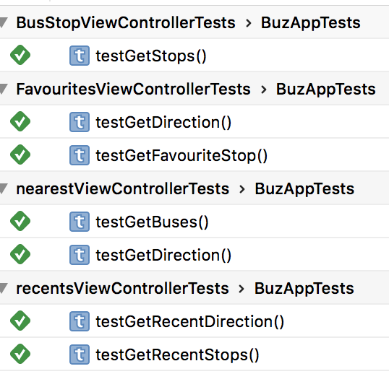The illustration below shows the unit test results after testing were successful.

**UI Test Results**

The illustration shows below the user interface test results after testing were successful.

